SE EXPERIMENT 6
Aim: To Study software estimation techniques like Function Point Analysis and COCOMO model and calculate the cost for Smart Parking Management System (SPMS).
- Function Point Analysis (FPA)
Function Point Analysis is a structured, technology-independent metric developed to quantify the software functionality delivered to a user based on external logical requirements. It evaluates functionality across five primary Information Domain Characteristics:
• External Inputs (EI): Elementary user/system data input transactions that update internal logical files.
• External Outputs (EO): Elementary processes that compute and present derived data or reports to users.
• External Inquiries (EQ): Input-output combinations resulting in immediate data retrieval without database modification.
• Internal Logical Files (ILF): User-identifiable logical data groups maintained entirely within system boundaries.
• External Interface Files (EIF): Data groups referenced by the application but maintained by external software systems.
The calculation derives Unadjusted Function Points (UFP) and adjusts them using the Value Adjustment Factor (VAF) based on 14 General System Characteristics (Fi):
VAF = 0.65 + 0.01 × (Σ Fi)
Final FP = UFP × VAF

2. COCOMO II (Object Point & Size Estimation Model)
COCOMO II (Constructive Cost Model) Early Prototyping/Application Composition model estimates project effort from direct system components (screens, reports, 3GL programming modules). The raw Object Points (OP) are adjusted for component reuse to obtain New Object Points (NOP):
NOP = OP × [(100 - % reuse) / 100]
Effort (Person-Months) = NOP / PROD
where PROD represents developer team productivity determined by developer experience and tool/environment maturity.

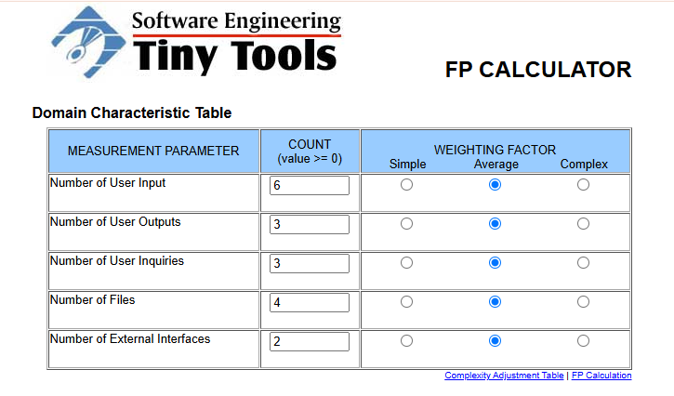
Information Domain Characteristics Table (UFP Calculation)
Unadjusted Function Points (UFP) = 24 + 15 + 12 + 40 + 14 = 105

General System Characteristics (Complexity Adjustment Table)
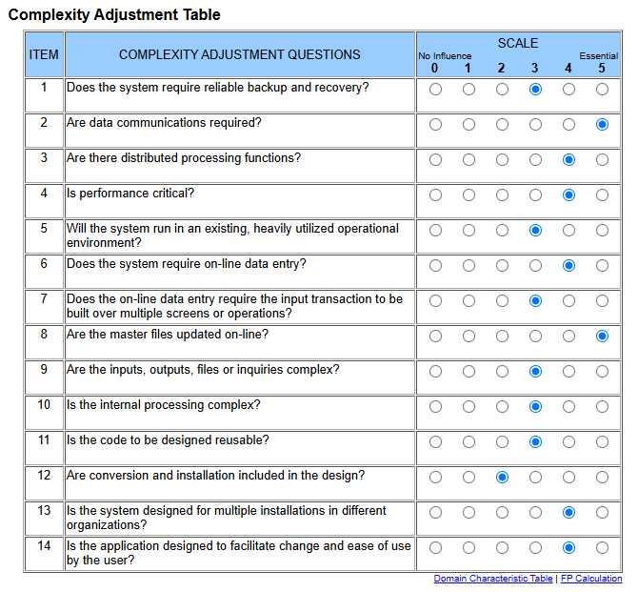

Calculation of Adjusted Function Points:
• Total Degree of Influence (Σ Fi) = 3 + 5 + 4 + 4 + 3 + 4 + 3 + 5 + 3 + 3 + 3 + 2 + 4 + 4 = 50
• Value Adjustment Factor (VAF) = 0.65 + 0.01 × (50) = 0.65 + 0.50 = 1.15
• Project Function Points (FP) = UFP × VAF = 105 × 1.15 = 120.75 FP
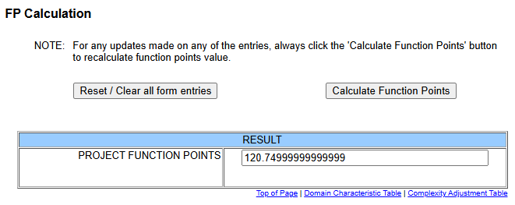
Cost Estimation via Standard Function Point Model:
• Assumption: 1 FP = ₹1,450 units (standard industry reference model)
• Estimated Total Cost = FP × ₹1,450 = 120.75 × ₹1,450 = ₹1,75,087.50

3. COCOMO Model & Size/Effort Estimation

1. Object Point Count & Complexity Classification
• Screens Breakdown:
1. Authentication & Registration Screen — Simple (Weight: 1)
2. Live Slot Availability & Map View Screen — Medium (Weight: 2)
3. Interactive Parking Grid & Reservation Modal — Medium (Weight: 2)
4. Payment & Checkout Screen — Medium (Weight: 2)
5. Facility Manager Override & Configuration Dashboard — Difficult (Weight: 3)
• Reports Breakdown:
1. Dynamic Parking Bill & PDF Invoice — Simple (Weight: 2)
2. Daily Facility Analytics & Revenue Report — Medium (Weight: 5)

• 3GL Components Breakdown:
1. Node.js / Express Backend & WebSockets Real-Time Engine — Difficult (Weight: 10)
2. MQTT Broker & IoT Sensor Hardware Interface Engine — Difficult (Weight: 10)

Complexity Weights and Object Point Matrix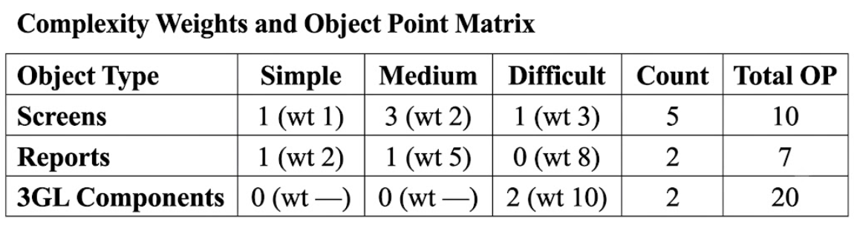
Total Object Points (OP) = 10 + 7 + 20 = 37
2. New Object Point (NOP) Calculation:
• Code Reusability (% reuse) = 15% (standard UI boilerplates, Express routers, client SDKs)
• NOP = OP × [(100 - % reuse) / 100] = 37 × [(100 - 15) / 100] = 37 × 0.85 = 31.45
New Object Point = 31.45
3. Developer Productivity Rate (PROD) & Effort Calculation:
• Developer Experience = Nominal / Medium (13 NOP/month)
• Development Environment Maturity = Nominal / Medium (13 NOP/month)
Productivity Rate (PROD) = (13 + 13) / 2
= 13 NOP / Person-Month
• Estimated Effort = NOP / PROD = 31.45 / 13 = 2.42 Person-Months
Efforts for project development is 2.42 person months.
4. Size Estimation (KLOC):
• Using calculated FP = 120.75 and 3GL conversion ratio (1 FP = 45 LOC for Node.js or JavaScript):
• Estimated Codebase Size = 120.75 × 45 = 5,433.75 LOC = 5.434 KLOC
Estimated Codebase Size = 5.434 KLOC
5. Schedule & Labor Cost Estimation:
• Development Time (TDEV) = 2.5 × (Effort)^0.35 = 2.5 × (2.42)^0.35 = 3.40 Months
• Labor Cost Estimation (at standard rate of ₹40,000 / Person-Month):
• Total Labor Cost = 2.42 Person-Months × ₹40,000
= ₹96,800.00
Total Labor Cost = ₹96,800.00

Conclusion:
Function Point Analysis and the COCOMO II Object Point model were successfully studied and applied to the Smart Parking Management System (SPMS). The system was evaluated at 120.75 Function Points, corresponding to an estimated codebase size of 5.434 KLOC. The required development effort was determined to be 2.42 Person-Months across an estimated schedule of 3.40 calendar months. Total project costs were calculated at ₹1,75,087.50 using the standard FP rate and ₹96,800.00 in direct labor costs. These metrics provide reliable baselines for sizing, budgeting, and project scheduling.

